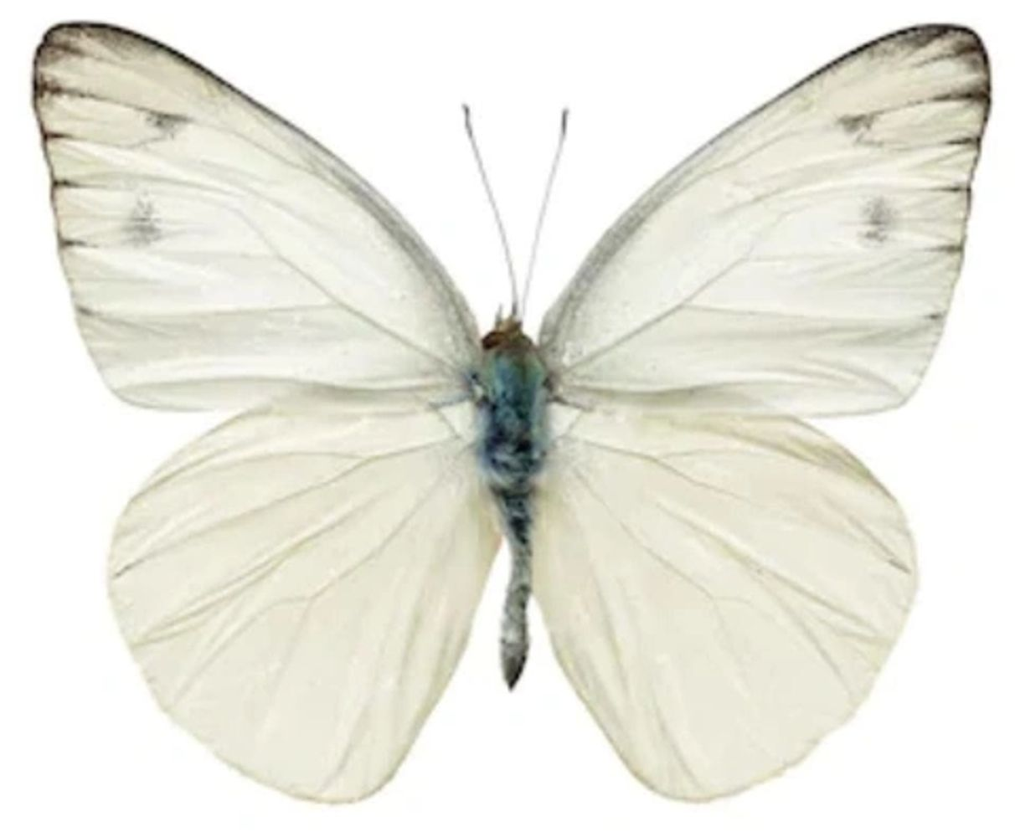

2024 VOLUNTEER FORM for Project White Butterfly’s
2nd Annual Butterfly Bash

[ ] YES! I am interested in volunteering at the 2nd Annual Butterfly Bash presented by Trionetics on July 20th

CONTACT NAME
COMPANY NAME (to appear in program)
ADDRESS
CITY STATE ZIP
PHONE FAX ___________________________________
E-mail ______________________________________________________________________________________
Please check off 3-4 areas that may interest you to be involved with at this event. Assignments will be made closer to the date of the event.

- Gathering of baskets for display and delivery to the event, day before
- Set up for day of, 9 am -11 am
- Welcome Ambassadors, 2 shifts
- Registration table, sign in, 2 shifts
- Volunteer Coordinator, all day 9 am – 3 pm
- Silent Auction or Basket Raffle Auction assistance, 2 shifts
- 50/50 raffle assistance, 2 shifts
- Day of and Public Relations Assistant, all day 9 am – 3 pm
- Close out, end of event day 2 pm-4 pm
- Final pack up of the event, 2 pm- 4 pm

Thank you for helping to advance the growth of Project White Butterfly’s mission!

Please return to:

ATTN: Sara Szelogowski

Project White Butterfly
7452 Broadview Road, #148, Parma, Ohio 44134

216-727-8725 (phone) ♦ support@projectwhitebuttefly.org (email)

